SPARK: Simple Play Adaptations to Reference for Kids

Feelings Chart and Cards
Description: | Image:
Each Feelings Chart comes equipped with 1 felt background board/ folder, 1 "I Feel" card, 19 feelings felt-backed cards, 1 "I Need" card, 19 activities felt-backed cards. Emotion cards can help children identify their own feelings and emotions. Students can put emotion cards corresponding to the emotions they feel every day (such as happy, excited, shy, bored, angry, sad, scared, nervous, worried, etc.) onto the feelings chart to help teachers and parents better understand children's feelings. The activities cards can help them identify strategies to help them feel better. | 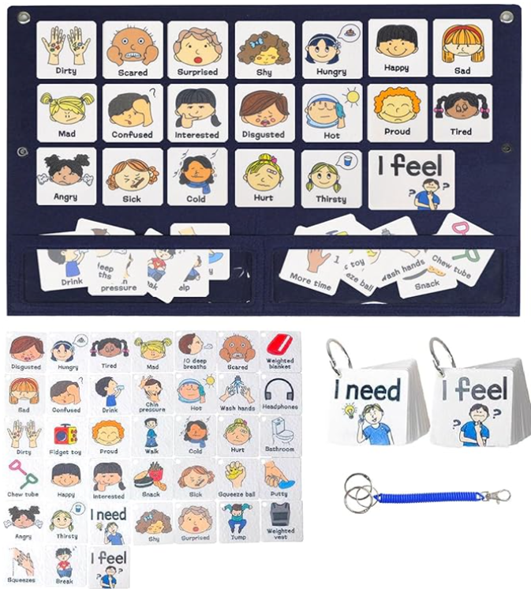

Who Might Benefit?
Those who…
• Have difficulty identifying their feelings.
• Need support determining what to do when they have certain feelings.
• Have motor challenges and are unable to draw pictures depicting feelings.
• Are challenged to self-regulate when they feel certain emotions.
• Have difficulty expressing their needs when upset, angry, scared etc.

Why Use?
Provides an opportunity to…
• Identify various feelings based on facial expressions.
• Talk about feelings.
• Show how they are feeling by indicating a picture.
• Recognize they have choices about what they can do to change how they are feeling.
• Make decisions about what they need to feel better.
Instructions for Use: | Adaptation Ideas:
Environmental Considerations  - Some children might do better with a one-on-one discussion of feelings rather than in a whole group setting.  - A quiet, more private area of the classroom could be considered for a child who has difficulty talking about or controlling their feelings.  - Chart could be displayed in the circle time area of the classroom and referenced daily.  Positioning  - Use in a variety of positions, however it is important that the user(s) are able to view them and reach them easily.  Basic Play/Use  - Use in a one-on-one setting, or during whole group activities.  Extended Play/Use  - Point out opportunities/area in the classroom where some of the “needs” identified on the cards can be met (e.g. earphones, break, fidget, bathroom).  Play/Use with Others  - During group time, have children share their feelings and why they feel that way.  - If a child identifies feeling other than “happy” or “surprised”, encourage the group to talk about what could be done to make the child feel better.  - Take pictures of the children making faces to express emotions. Print, laminate, and bind to make a feelings book for the classroom library. See OCALI Social Narrative Example, Feeling Anxious and Worried.  - When reading stories, refer to the chart and ask children how characters might be feeling.  - Have children draw cards and mimic the facial expression or actions depicted on cards.  - Use cards to select feelings and needs and incorporate into new words and actions for “If You’re Happy and You Know It” song. | Optional Additional Materials/Supplies  - Laminator  - Velcro  - Foam Board  Build It Up  - Consider mounting pictures on foam board and add Velcro to the backs.  Stabilize It  - Smaller number of cards could be arranged on a trifold display board made from foam core board.  Simplify It  - Reduce the number of emotions discussed (ex. happy, sad, mad, sick, scared) or stamps being used based on the child’s understanding.  Add Sensory Cues  - Add puff paint or Wikki Stix to trace outlines of pictures.  Communication Support  - Record feelings on a voice output device (e.g. GoTalk One) with added visual support representing the recorded feeling.  DIY Alternatives  - Use chart paper and drawings of stamps to illustrate feelings and needs.

Resources:

See Social Narratives from OCALI’s Autism Center Grab and Go Resource Gallery of Interventions.
- For further information, visit the Social Narratives Autism Internet Module.
- Like Social Stories, Power Cards teach and reinforce academic, behavioral, organizational, and social skills. Power Cards are visual supports that include an individual’s special interest. See Power Cards from OCALI’s Autism Center Grab and Go Resource Gallery of Interventions.
- Reminder Cue Cards from OCALI’s Autism Center Grab and Go Resource Gallery of Interventions help teach and remind individuals how to engage in positive behaviors. Reminder Cue Cards provide “what to do” suggestions when an individual is feeling anxious, stressed, or confused. They also support interactions with peers, and offer ways to self-regulate, and manage emotions.
- Practical Strategy for Teachers/Caregivers: Teaching Social Emotional Skills from the Center on the Social Emotional Foundations for Early Learning.

Additional Considerations

Be sure to incorporate wait time when child is struggling with their feelings and may be unable to identify their feelings or what to do about them. This may require removing other children to another location and providing the child a quiet space to regroup.

Ohio Early Learning Standards:
- SE: Self Awareness: Develops an understanding of emotions (1.b.).
- SE: Self Awareness: Begins to manage emotions and actions (2.a.).
- SE: Social Awareness: Develops empathy toward and understanding of others (3 a.).
- SE: Relationship Skills: Develops ability to use simple strategies to resolve conflicts with peers (4.c.).

Words to Encourage Play/Use
I feel  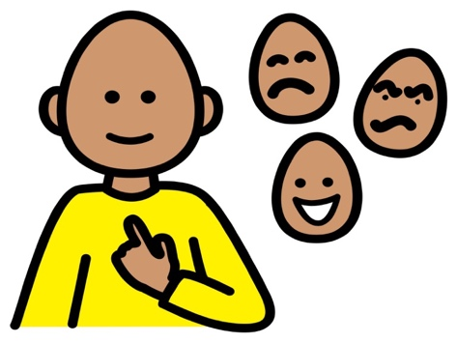 | Happy | Sad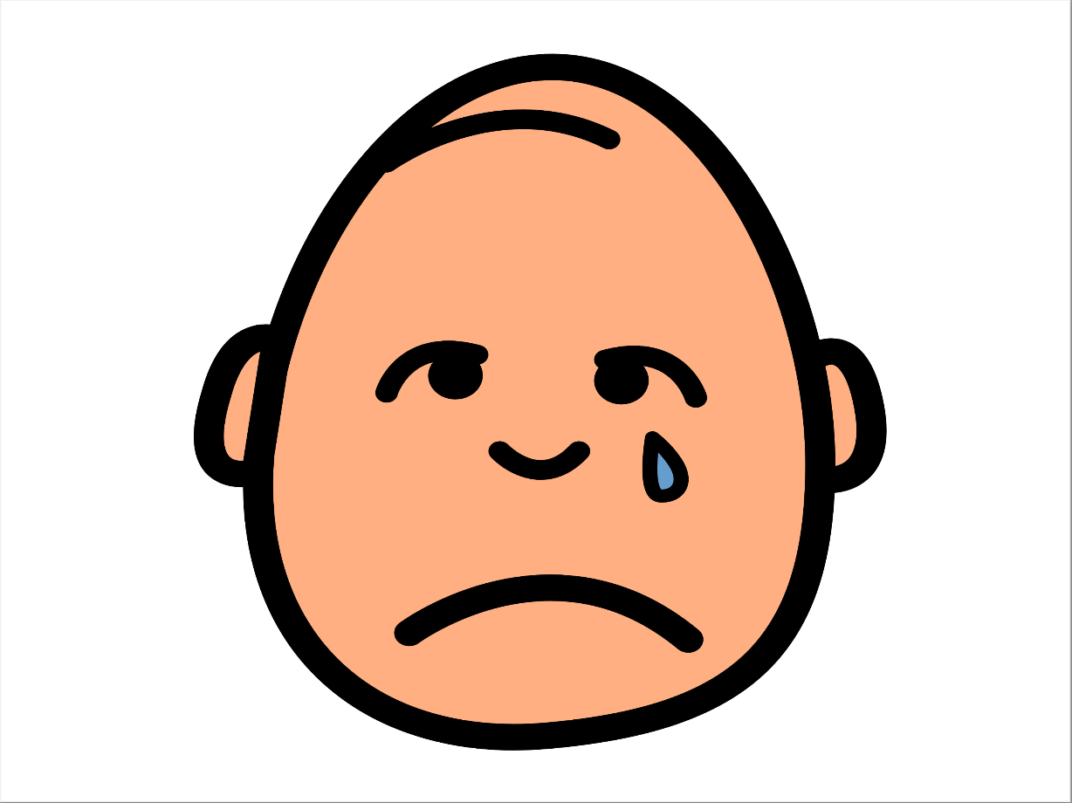
Sick | Surprised | Tired 
Confused | Mad | Scared  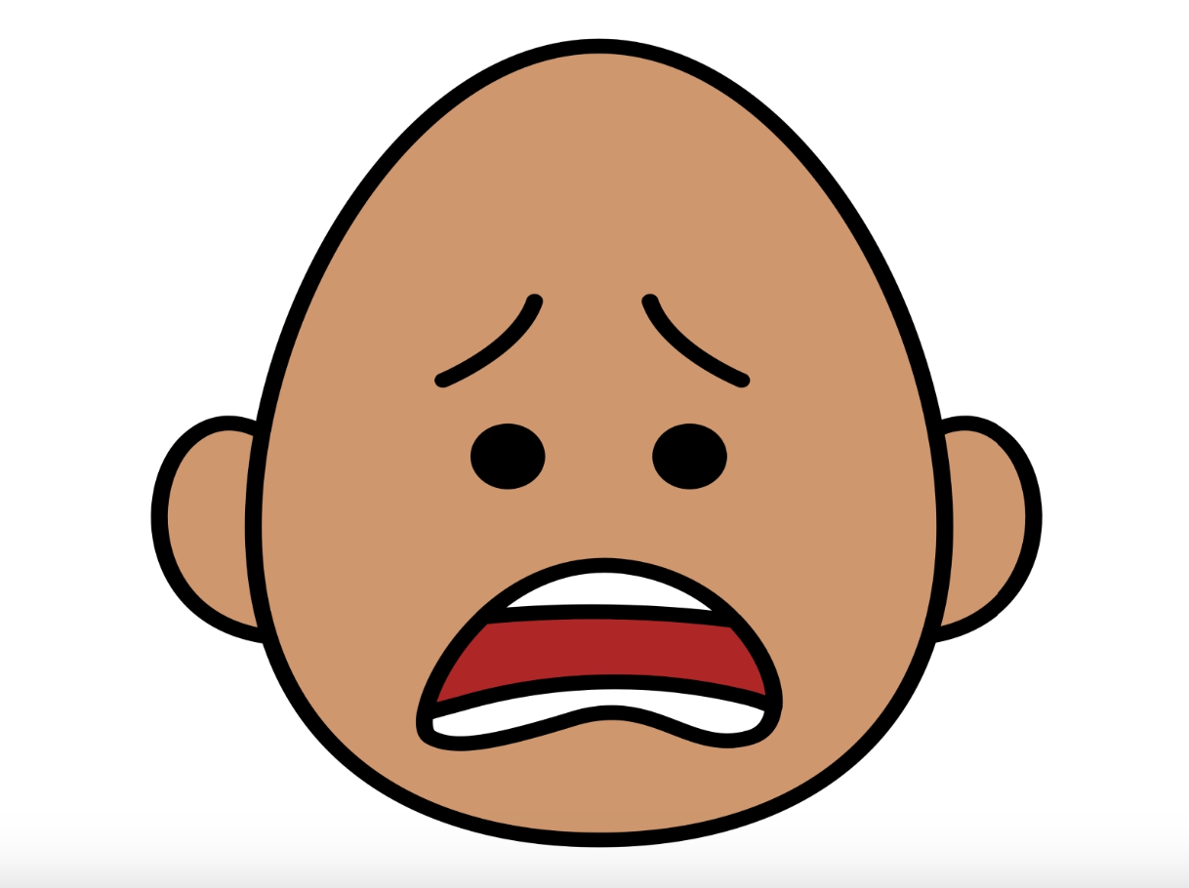
*”Adaptations” adapted from: Haugen’s Modes for Adapting Toys based on materials from the "Let's Play" Project at the University of Buffalo
PCS is a trademark of Tobii Dynavox, LLC. All rights reserved. Used with permission.

